PRN232 PRACTICAL EXAM – FALL25

Họ và tên: Lê Võ Bảo Duy
QE180054

Link GitHub: https://github.com/BaoDuy1703/Movie-Collection.git
Link Deploy: https://movie-collection-sb2i.onrender.com

Features:
- Main Page

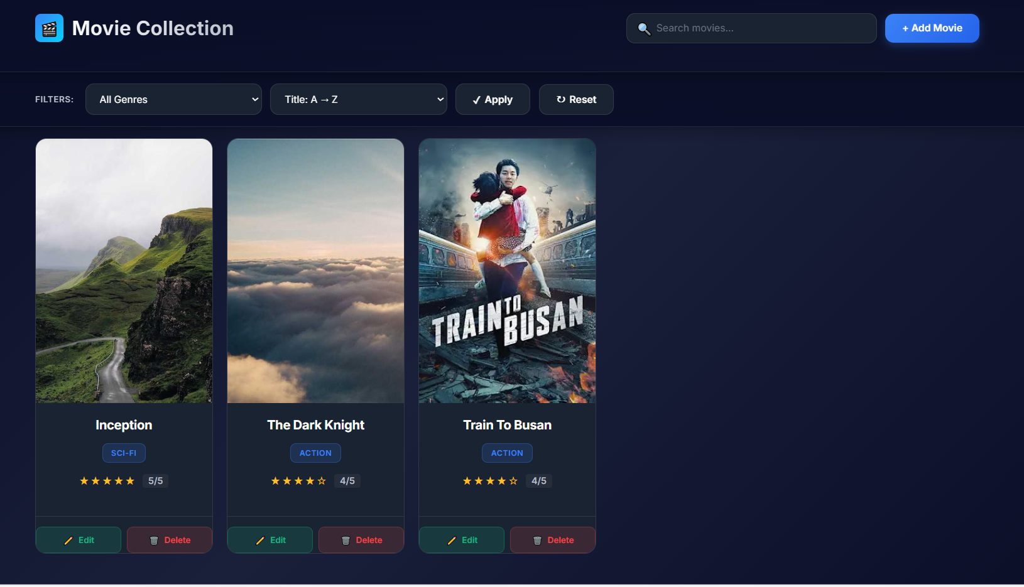

- Add Movie

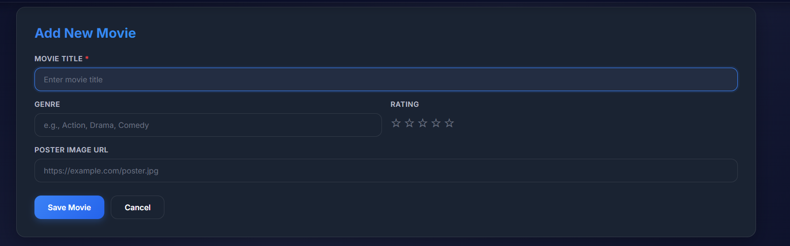

- Edit Movie

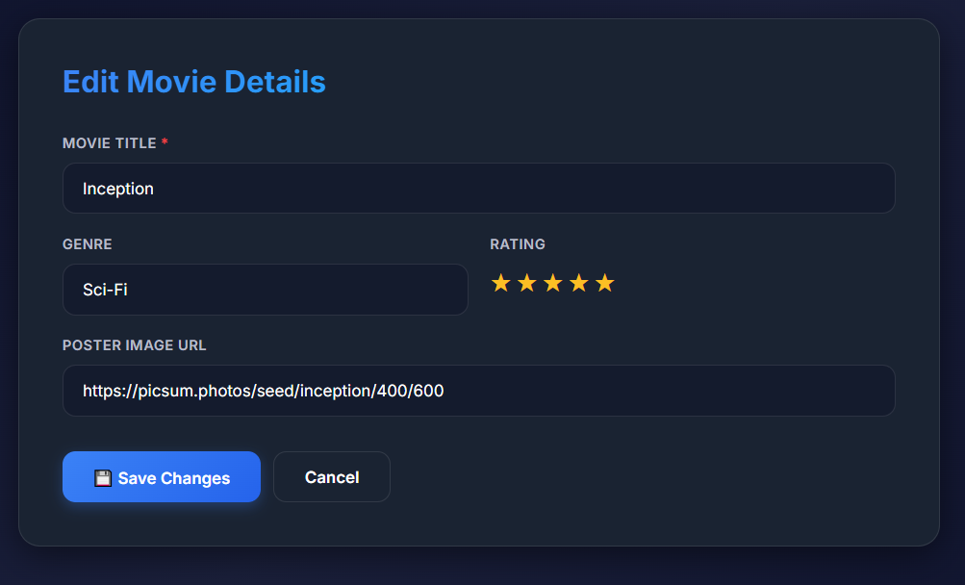

- Delete a Movie
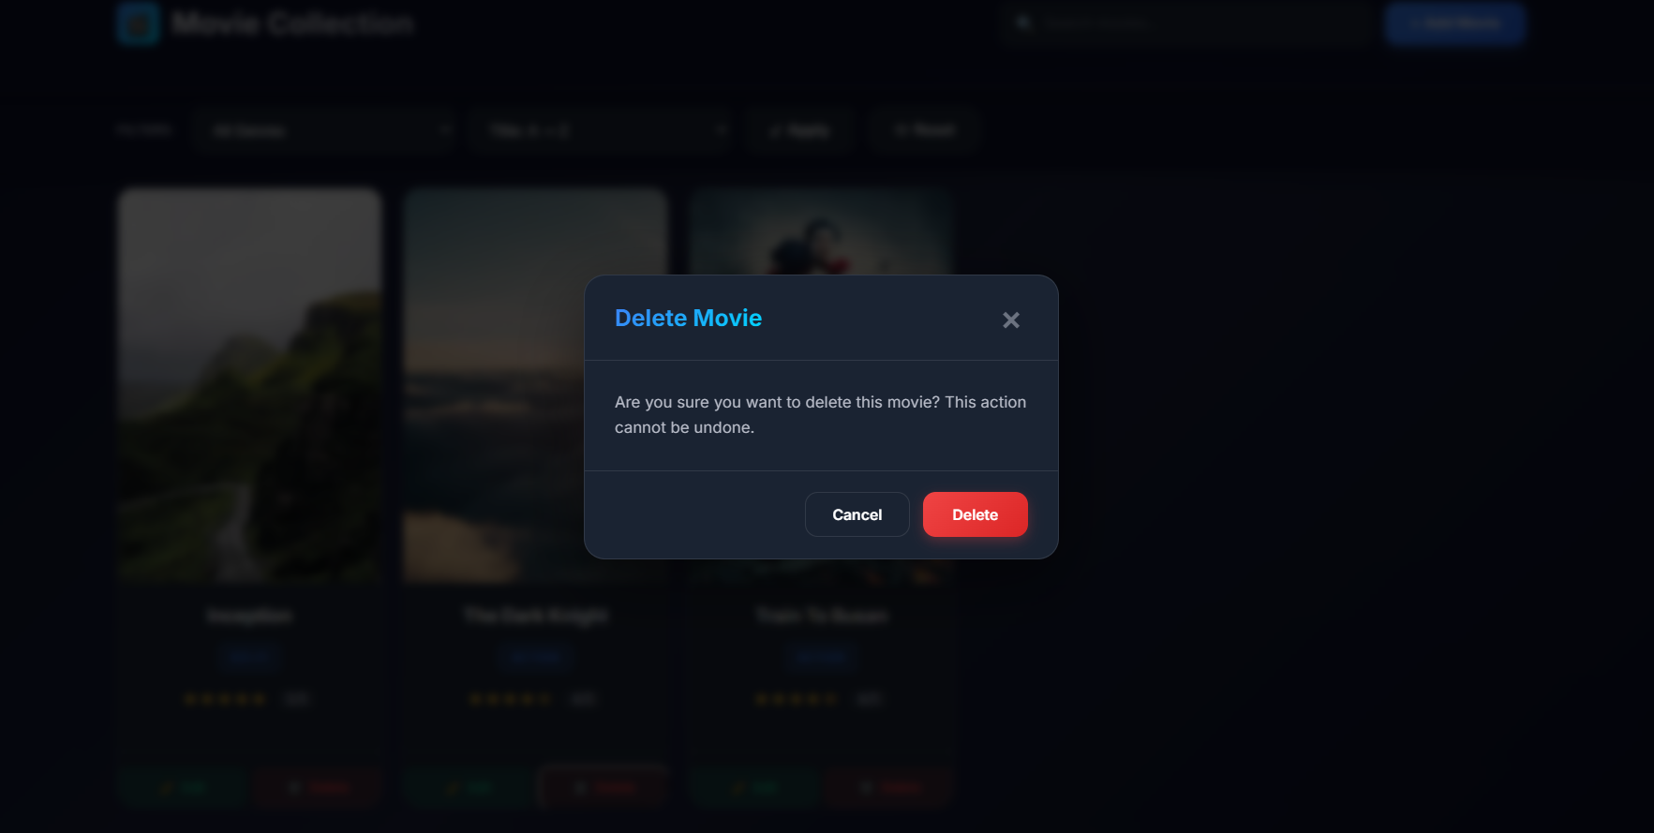

- Filters

